# DATOS GENERALES

Número Pase a Producción : PAS20181U220200056

Código y Nombre del

Proyecto : P_SNAA0004-84

Nombre del F2 : F2_3014_ana_dis.docx

Programador : Ana Rey Gonzáles

Fecha de Informe : 26/03/2019

Nombre del Sistema. : SDA - DESPACHO

Nombre del Sub Sistema : Consultas y Reportes

Modulo del Sistema : 3014

# ALCANCE DE LA PRUEBA

Reporte Detallado de Certificado de Origen Electrónico

Reporte Ejecutivo de Certificado de Origen Electrónico

# DETALLE DE LA PRUEBA

|  |  |  |  |
| --- | --- | --- | --- |
| **N° DEL REQUERIMIENTO FUNCIONAL Y NO FUNCIONAL** | **RIM** | **SOFTWARE** | **DATOS DE ENTRADA** |
| RF1 Reporte Ejecutivo | El Reporte Ejecutivo mostrará los Criterios de Búsqueda y permitirá exportar el resultado en Excel y PDF | Reporte Ejecutivo | Rango de fecha  Tipo de reporte  Nivel de Reporte  Tipo de Emisor  TPI  País de Origen |
|  | | | |
|  | | | |
| Se ingresa a la opción Reporte Ejecutivo y se verificará que los filtros y el resultado de los reportes funcionen de acuerdo a lo solicitado en las reglas del RF1.  **RUTA OPCION:** Despacho aduanero de ingreso/Reportes/ Reporte Ejecutivo Certificado  **Cantidad de Certificados de Origen Electrónicos remitidos por la VUCE:**      Query:  SELECT "codEmision" ,"codTpiCO","codPaisOrigen" ,Sum("Campo1")||','|| Sum ("Campo2")||','|| Sum ("Campo3")||','|| Sum ("Campo4")||','|| Sum ("Campo5")||','|| Sum ("Campo6")||','|| Sum ("Campo7")||','|| Sum ("Campo8")||','|| Sum ("Campo9")||','|| Sum ("Campo10")||','|| Sum ("Campo11")||','|| Sum ("Campo12")||','|| Sum ("Campo13") as "cadenaResul" FROM ( SELECT DISTINCT (repo.num_corredoc), '' AS "codEmision", '' as "codTpiCO", c.cod_datacat || '-' || c.des_datacat AS "codPaisOrigen", TO_CHAR (repo.fec_regis, 'mm/yyyy') AS fecha FROM doccertorigen repo , datacatalogo c WHERE trunc(repo.fec_regis) BETWEEN trunc(?) AND trunc(?) AND SUBSTR (repo.cod_paisenthabili, 0, 2) = c.cod_datacat AND c.cod_catalogo = 'J2' AND repo.ind_usocertorigen!='D' UNION SELECT DISTINCT (repo.num_corredoc), '' AS "codEmision", '' as "codTpiCO", c.cod_datacat || '-' || c.des_datacat AS "codPaisOrigen", TO_CHAR (repo.fec_regis, 'mm/yyyy') AS fecha FROM doccertorigen repo , datacatalogo c , cab_certiorigen cert , cab_declara dam , participante_doc part , docaut_asociado doc , det_autorizacion det , det_declara decl , convenio_serie conv WHERE trunc(repo.fec_regis) BETWEEN trunc(?) AND trunc(?) AND SUBSTR (repo.cod_paisenthabili, 0, 2) = c.cod_datacat AND c.cod_catalogo = 'J2' AND (repo.num_certorigen = cert.num_certificado and cert.ind_electronico = '1' and cert.ind_del = '0') AND (cert.num_corredoc = dam.num_corredoc) AND (dam.num_corredoc = part.num_corredoc and part.cod_tippartic = '45') AND (cert.num_corredoc = doc.num_corredoc and cert.num_secdoc = doc.num_secdoc and cert.cod_tipoper = doc.cod_tipoper and doc.num_doc=cert.num_certificado and doc.ind_del='0') AND (doc.num_corredoc = det.num_corredoc and doc.num_secdoc = det.num_secdoc and doc.cod_tipoper = det.cod_tipoper and det.ind_del = '0') AND (det.num_corredoc=decl.num_corredoc and det.num_secserie=decl.num_secserie and decl.ind_del='0') AND (conv.num_corredoc=decl.num_corredoc and conv.num_secserie=decl.num_secserie and conv.ind_del='0') AND conv.cod_convenio = ? AND repo.ind_usocertorigen ='D' ) PIVOT (COUNT (num_corredoc) FOR fecha IN ('01/2018' AS "Campo1",'02/2018' AS "Campo2",'03/2018' AS "Campo3",'04/2018' AS "Campo4",'05/2018' AS "Campo5",'06/2018' AS "Campo6",'07/2018' AS "Campo7",'08/2018' AS "Campo8",'09/2018' AS "Campo9",'10/2018' AS "Campo10",'11/2018' AS "Campo11",'12/2018' AS "Campo12", 0 AS "Campo13", 0 AS "Campo14", 0 AS "Campo15", 0 AS "Campo16", 0 AS "Campo17", 0 AS "Campo18", 0 AS "Campo19", 0 AS "Campo20", 0 AS "Campo21", 0 AS "Campo22", 0 AS "Campo23", 0 AS "Campo24", 0 AS "Campo25", 0 AS "Campo26", 0 AS "Campo27", 0 AS "Campo28", 0 AS "Campo29", 0 AS "Campo30", 0 AS "Campo31") ) tabla group by "codEmision","codTpiCO","codPaisOrigen" ORDER BY "codTpiCO","codPaisOrigen"    Parameters: [2018-01-01 00:00:00.0, 2018-12-29 00:00:00.0, 2018-01-01 00:00:00.0, 2018-12-29 00:00:00.0, 815] | | | |

**Cantidad de Certificados de Origen Electrónicos vinculados a declaraciones:**

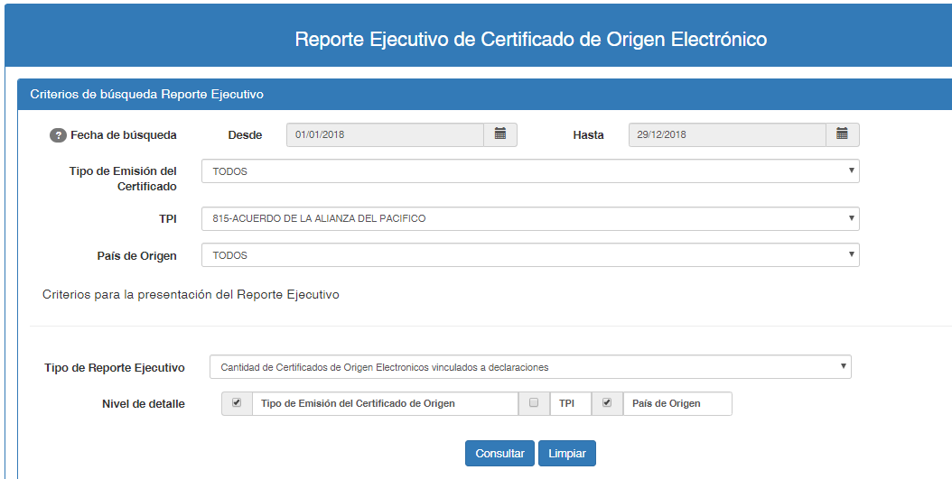

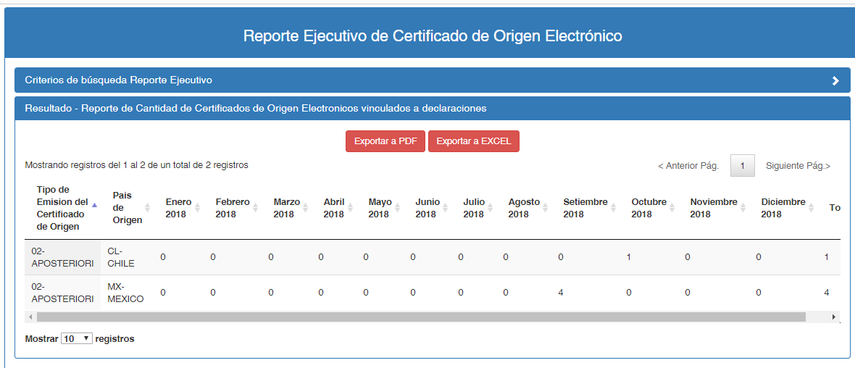

QUERY:

SELECT "codEmision" ,"codTpiCO","codPaisOrigen" ,Sum("Campo1")||','|| Sum ("Campo2")||','|| Sum ("Campo3")||','|| Sum ("Campo4")||','|| Sum ("Campo5")||','|| Sum ("Campo6")||','|| Sum ("Campo7")||','|| Sum ("Campo8")||','|| Sum ("Campo9")||','|| Sum ("Campo10")||','|| Sum ("Campo11")||','|| Sum ("Campo12")||','|| Sum ("Campo13") as "cadenaResul" FROM ( SELECT DISTINCT (repo.num_corredoc), b.cod_datacat || '-' || b.des_datacat AS "codEmision", conv.cod_convenio as "codTpiCO", c.cod_datacat || '-' || c.des_datacat AS "codPaisOrigen", TO_CHAR (repo.fec_regis, 'mm/yyyy') AS fecha FROM doccertorigen repo , datacatalogo b , datacatalogo c , cab_certiorigen cert , cab_declara dam , participante_doc part , docaut_asociado doc , det_autorizacion det , det_declara decl , convenio_serie conv WHERE trunc(repo.fec_regis) BETWEEN trunc(?) AND trunc(?) AND SUBSTR (repo.cod_tipemision, 0, 2) = b.cod_datacat AND b.cod_catalogo = 'COA' AND SUBSTR (repo.cod_paisenthabili, 0, 2) = c.cod_datacat AND c.cod_catalogo = 'J2' AND (repo.num_certorigen = cert.num_certificado and cert.ind_electronico = '1' and cert.ind_del = '0') AND (cert.num_corredoc = dam.num_corredoc) AND (dam.num_corredoc = part.num_corredoc and part.cod_tippartic = '45') AND (cert.num_corredoc = doc.num_corredoc and cert.num_secdoc = doc.num_secdoc and cert.cod_tipoper = doc.cod_tipoper and doc.num_doc=cert.num_certificado and doc.ind_del='0') AND (doc.num_corredoc = det.num_corredoc and doc.num_secdoc = det.num_secdoc and doc.cod_tipoper = det.cod_tipoper and det.ind_del = '0') AND (det.num_corredoc=decl.num_corredoc and det.num_secserie=decl.num_secserie and decl.ind_del='0') AND (conv.num_corredoc=decl.num_corredoc and conv.num_secserie=decl.num_secserie and conv.ind_del='0') AND conv.cod_convenio = ? AND repo.ind_usocertorigen ='D' ) PIVOT (COUNT (num_corredoc) FOR fecha IN ('01/2018' AS "Campo1",'02/2018' AS "Campo2",'03/2018' AS "Campo3",'04/2018' AS "Campo4",'05/2018' AS "Campo5",'06/2018' AS "Campo6",'07/2018' AS "Campo7",'08/2018' AS "Campo8",'09/2018' AS "Campo9",'10/2018' AS "Campo10",'11/2018' AS "Campo11",'12/2018' AS "Campo12", 0 AS "Campo13", 0 AS "Campo14", 0 AS "Campo15", 0 AS "Campo16", 0 AS "Campo17", 0 AS "Campo18", 0 AS "Campo19", 0 AS "Campo20", 0 AS "Campo21", 0 AS "Campo22", 0 AS "Campo23", 0 AS "Campo24", 0 AS "Campo25", 0 AS "Campo26", 0 AS "Campo27", 0 AS "Campo28", 0 AS "Campo29", 0 AS "Campo30", 0 AS "Campo31") ) tabla group by "codEmision","codTpiCO","codPaisOrigen" ORDER BY "codEmision" ,"codTpiCO","codPaisOrigen"

Parameters: [2018-01-01 00:00:00.0, 2018-12-29 00:00:00.0, 815]

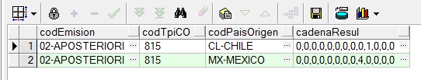

EXPORTAR:

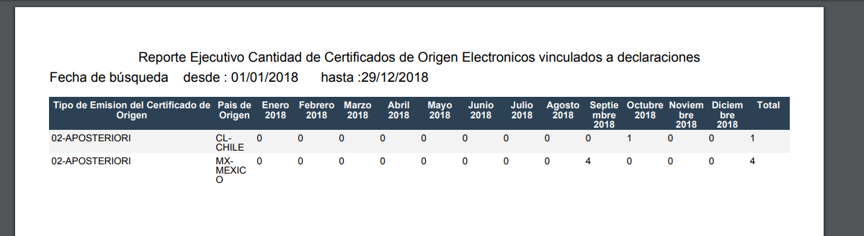

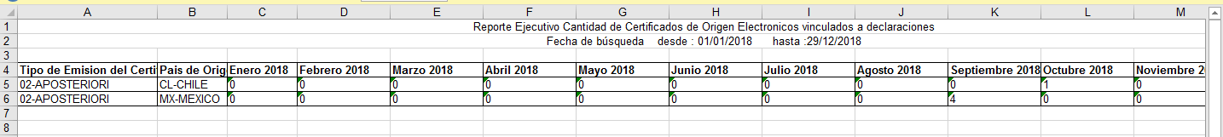

**Cantidad de Certificados de Origen Electrónicos remitidos por la VUCE:**

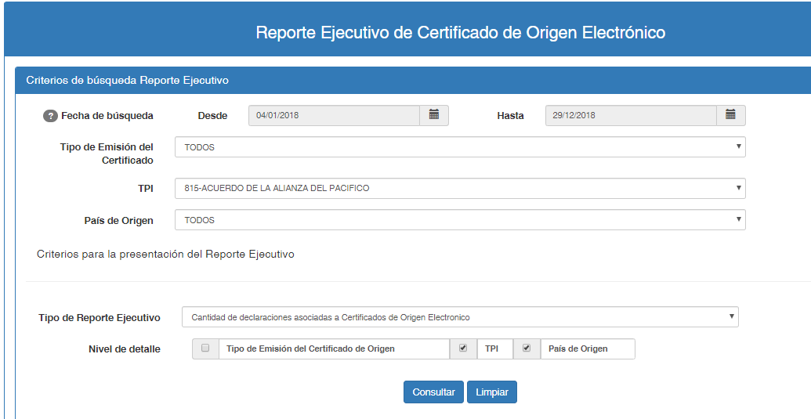

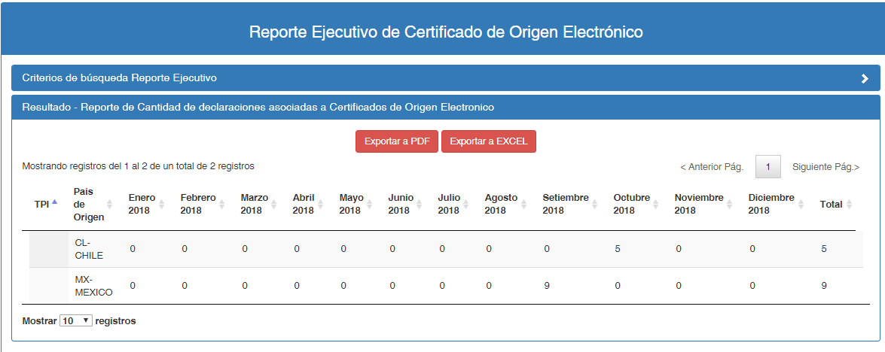

QUERY:

SELECT "codEmision" ,"codTpiCO","codPaisOrigen" ,Sum("Campo1")||','|| Sum ("Campo2")||','|| Sum ("Campo3")||','|| Sum ("Campo4")||','|| Sum ("Campo5")||','|| Sum ("Campo6")||','|| Sum ("Campo7")||','|| Sum ("Campo8")||','|| Sum ("Campo9")||','|| Sum ("Campo10")||','|| Sum ("Campo11")||','|| Sum ("Campo12")||','|| Sum ("Campo13") as "cadenaResul" FROM ( SELECT DISTINCT (cert.num_corredoc), '' AS "codEmision", '' as "codTpiCO", c.cod_datacat || '-' || c.des_datacat AS "codPaisOrigen", TO_CHAR (repo.fec_regis, 'mm/yyyy') AS fecha FROM doccertorigen repo , datacatalogo c , cab_certiorigen cert , cab_declara dam , participante_doc part , docaut_asociado doc , det_autorizacion det , det_declara decl , convenio_serie conv WHERE trunc(repo.fec_regis) BETWEEN trunc(?) AND trunc(?) AND SUBSTR (repo.cod_paisenthabili, 0, 2) = c.cod_datacat AND c.cod_catalogo = 'J2' AND (repo.num_certorigen = cert.num_certificado and cert.ind_electronico = '1' and cert.ind_del = '0') AND (cert.num_corredoc = dam.num_corredoc) AND (dam.num_corredoc = part.num_corredoc and part.cod_tippartic = '45') AND (cert.num_corredoc = doc.num_corredoc and cert.num_secdoc = doc.num_secdoc and cert.cod_tipoper = doc.cod_tipoper and doc.num_doc=cert.num_certificado and doc.ind_del='0') AND (doc.num_corredoc = det.num_corredoc and doc.num_secdoc = det.num_secdoc and doc.cod_tipoper = det.cod_tipoper and det.ind_del = '0') AND (det.num_corredoc=decl.num_corredoc and det.num_secserie=decl.num_secserie and decl.ind_del='0') AND (conv.num_corredoc=decl.num_corredoc and conv.num_secserie=decl.num_secserie and conv.ind_del='0') AND conv.cod_convenio = ? AND repo.ind_usocertorigen ='D' ) PIVOT (COUNT (num_corredoc) FOR fecha IN ('01/2018' AS "Campo1",'02/2018' AS "Campo2",'03/2018' AS "Campo3",'04/2018' AS "Campo4",'05/2018' AS "Campo5",'06/2018' AS "Campo6",'07/2018' AS "Campo7",'08/2018' AS "Campo8",'09/2018' AS "Campo9",'10/2018' AS "Campo10",'11/2018' AS "Campo11",'12/2018' AS "Campo12", 0 AS "Campo13", 0 AS "Campo14", 0 AS "Campo15", 0 AS "Campo16", 0 AS "Campo17", 0 AS "Campo18", 0 AS "Campo19", 0 AS "Campo20", 0 AS "Campo21", 0 AS "Campo22", 0 AS "Campo23", 0 AS "Campo24", 0 AS "Campo25", 0 AS "Campo26", 0 AS "Campo27", 0 AS "Campo28", 0 AS "Campo29", 0 AS "Campo30", 0 AS "Campo31") ) tabla group by "codEmision","codTpiCO","codPaisOrigen" ORDER BY "codTpiCO","codPaisOrigen"

Parameters: [2018-01-04 00:00:00.0, 2018-12-29 00:00:00.0, 815]

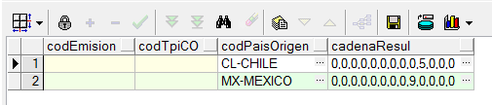

**Cantidad de Certificados Electrónicos marcados como declarados remitidas a VUCE:**

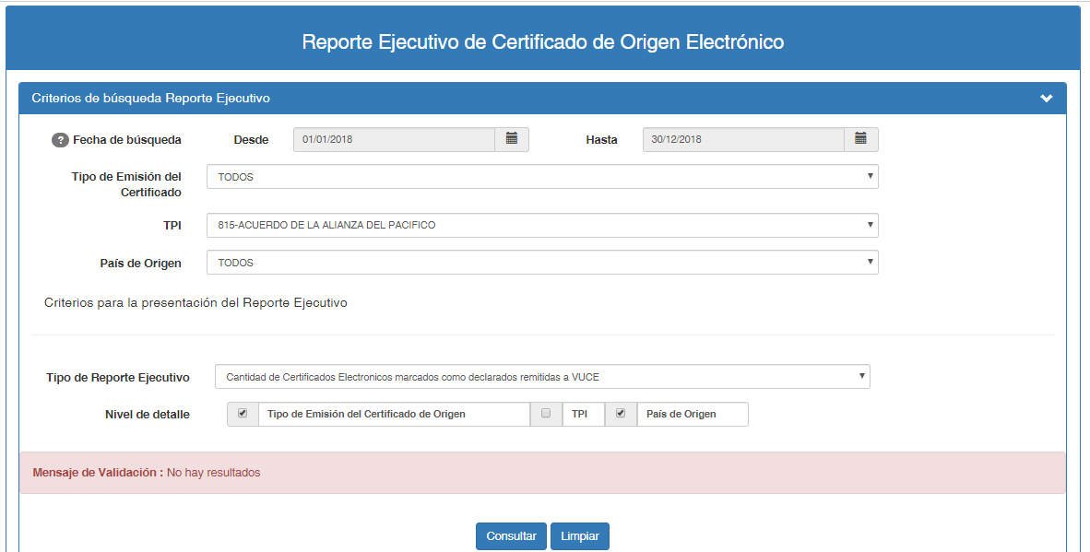

QUERY:

SELECT "codEmision" ,"codTpiCO","codPaisOrigen" ,Sum("Campo1")||','|| Sum ("Campo2")||','|| Sum ("Campo3")||','|| Sum ("Campo4")||','|| Sum ("Campo5")||','|| Sum ("Campo6")||','|| Sum ("Campo7")||','|| Sum ("Campo8")||','|| Sum ("Campo9")||','|| Sum ("Campo10")||','|| Sum ("Campo11")||','|| Sum ("Campo12")||','|| Sum ("Campo13") as "cadenaResul" FROM ( SELECT DISTINCT (cert.num_corredoc), b.cod_datacat || '-' || b.des_datacat AS "codEmision", conv.cod_convenio as "codTpiCO", c.cod_datacat || '-' || c.des_datacat AS "codPaisOrigen", TO_CHAR (repo.fec_regis, 'mm/yyyy') AS fecha FROM doccertorigen repo , datacatalogo b , datacatalogo c , cab_certiorigen cert , cab_declara dam , participante_doc part , docaut_asociado doc , det_autorizacion det , det_declara decl , convenio_serie conv , resultadoinvocaserv invoca WHERE invoca.num_corredoc = cert.num_corredoc AND invoca.cod_tipdocrspta='30' AND trunc(repo.fec_regis) BETWEEN trunc(?) AND trunc(?) AND SUBSTR (repo.cod_tipemision, 0, 2) = b.cod_datacat AND b.cod_catalogo = 'COA' AND SUBSTR (repo.cod_paisenthabili, 0, 2) = c.cod_datacat AND c.cod_catalogo = 'J2' AND (repo.num_certorigen = cert.num_certificado and cert.ind_electronico = '1' and cert.ind_del = '0') AND (cert.num_corredoc = dam.num_corredoc) AND (dam.num_corredoc = part.num_corredoc and part.cod_tippartic = '45') AND (cert.num_corredoc = doc.num_corredoc and cert.num_secdoc = doc.num_secdoc and cert.cod_tipoper = doc.cod_tipoper and doc.num_doc=cert.num_certificado and doc.ind_del='0') AND (doc.num_corredoc = det.num_corredoc and doc.num_secdoc = det.num_secdoc and doc.cod_tipoper = det.cod_tipoper and det.ind_del = '0') AND (det.num_corredoc=decl.num_corredoc and det.num_secserie=decl.num_secserie and decl.ind_del='0') AND (conv.num_corredoc=decl.num_corredoc and conv.num_secserie=decl.num_secserie and conv.ind_del='0') AND conv.cod_convenio = ? AND repo.ind_usocertorigen ='D' ) PIVOT (COUNT (num_corredoc) FOR fecha IN ('01/2018' AS "Campo1",'02/2018' AS "Campo2",'03/2018' AS "Campo3",'04/2018' AS "Campo4",'05/2018' AS "Campo5",'06/2018' AS "Campo6",'07/2018' AS "Campo7",'08/2018' AS "Campo8",'09/2018' AS "Campo9",'10/2018' AS "Campo10",'11/2018' AS "Campo11",'12/2018' AS "Campo12", 0 AS "Campo13", 0 AS "Campo14", 0 AS "Campo15", 0 AS "Campo16", 0 AS "Campo17", 0 AS "Campo18", 0 AS "Campo19", 0 AS "Campo20", 0 AS "Campo21", 0 AS "Campo22", 0 AS "Campo23", 0 AS "Campo24", 0 AS "Campo25", 0 AS "Campo26", 0 AS "Campo27", 0 AS "Campo28", 0 AS "Campo29", 0 AS "Campo30", 0 AS "Campo31") ) tabla group by "codEmision","codTpiCO","codPaisOrigen" ORDER BY "codEmision" ,"codTpiCO","codPaisOrigen"

Parameters: [2018-01-01 00:00:00.0, 2018-12-30 00:00:00.0, 815]

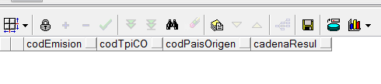

**Cantidad de Certificados Electrónicos marcados como anulados:**

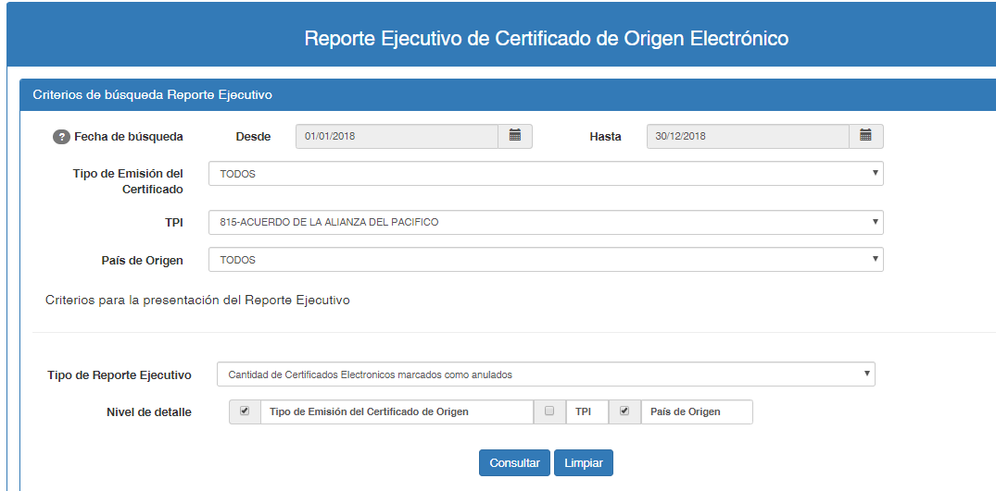

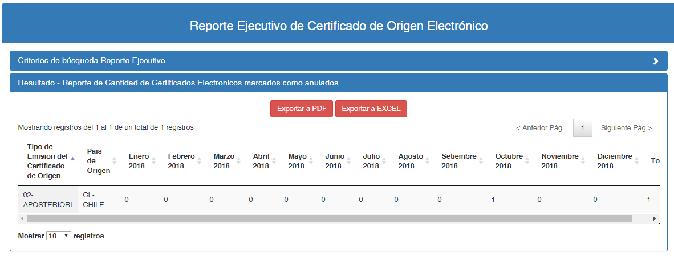

QUERY:

SELECT "codEmision" ,"codTpiCO","codPaisOrigen" ,Sum("Campo1")||','|| Sum ("Campo2")||','|| Sum ("Campo3")||','|| Sum ("Campo4")||','|| Sum ("Campo5")||','|| Sum ("Campo6")||','|| Sum ("Campo7")||','|| Sum ("Campo8")||','|| Sum ("Campo9")||','|| Sum ("Campo10")||','|| Sum ("Campo11")||','|| Sum ("Campo12")||','|| Sum ("Campo13") as "cadenaResul" FROM ( SELECT DISTINCT (repo.num_corredoc), b.cod_datacat || '-' || b.des_datacat AS "codEmision", '' as "codTpiCO", c.cod_datacat || '-' || c.des_datacat AS "codPaisOrigen", TO_CHAR (repo.fec_regis, 'mm/yyyy') AS fecha FROM doccertorigen repo , datacatalogo b , datacatalogo c WHERE trunc(repo.fec_regis) BETWEEN trunc(?) AND trunc(?) AND SUBSTR (repo.cod_tipemision, 0, 2) = b.cod_datacat AND b.cod_catalogo = 'COA' AND SUBSTR (repo.cod_paisenthabili, 0, 2) = c.cod_datacat AND c.cod_catalogo = 'J2' AND repo.ind_usocertorigen!='D' AND repo.ind_usocertorigen='A' UNION SELECT DISTINCT (repo.num_corredoc), b.cod_datacat || '-' || b.des_datacat AS "codEmision", conv.cod_convenio as "codTpiCO", c.cod_datacat || '-' || c.des_datacat AS "codPaisOrigen", TO_CHAR (repo.fec_regis, 'mm/yyyy') AS fecha FROM doccertorigen repo , datacatalogo b , datacatalogo c , cab_certiorigen cert , cab_declara dam , participante_doc part , docaut_asociado doc , det_autorizacion det , det_declara decl , convenio_serie conv WHERE trunc(repo.fec_regis) BETWEEN trunc(?) AND trunc(?) AND SUBSTR (repo.cod_tipemision, 0, 2) = b.cod_datacat AND b.cod_catalogo = 'COA' AND SUBSTR (repo.cod_paisenthabili, 0, 2) = c.cod_datacat AND c.cod_catalogo = 'J2' AND (repo.num_certorigen = cert.num_certificado and cert.ind_electronico = '1' and cert.ind_del = '0') AND (cert.num_corredoc = dam.num_corredoc) AND (dam.num_corredoc = part.num_corredoc and part.cod_tippartic = '45') AND (cert.num_corredoc = doc.num_corredoc and cert.num_secdoc = doc.num_secdoc and cert.cod_tipoper = doc.cod_tipoper and doc.num_doc=cert.num_certificado and doc.ind_del='0') AND (doc.num_corredoc = det.num_corredoc and doc.num_secdoc = det.num_secdoc and doc.cod_tipoper = det.cod_tipoper and det.ind_del = '0') AND (det.num_corredoc=decl.num_corredoc and det.num_secserie=decl.num_secserie and decl.ind_del='0') AND (conv.num_corredoc=decl.num_corredoc and conv.num_secserie=decl.num_secserie and conv.ind_del='0') AND conv.cod_convenio = ? AND repo.ind_usocertorigen='A' ) PIVOT (COUNT (num_corredoc) FOR fecha IN ('01/2018' AS "Campo1",'02/2018' AS "Campo2",'03/2018' AS "Campo3",'04/2018' AS "Campo4",'05/2018' AS "Campo5",'06/2018' AS "Campo6",'07/2018' AS "Campo7",'08/2018' AS "Campo8",'09/2018' AS "Campo9",'10/2018' AS "Campo10",'11/2018' AS "Campo11",'12/2018' AS "Campo12", 0 AS "Campo13", 0 AS "Campo14", 0 AS "Campo15", 0 AS "Campo16", 0 AS "Campo17", 0 AS "Campo18", 0 AS "Campo19", 0 AS "Campo20", 0 AS "Campo21", 0 AS "Campo22", 0 AS "Campo23", 0 AS "Campo24", 0 AS "Campo25", 0 AS "Campo26", 0 AS "Campo27", 0 AS "Campo28", 0 AS "Campo29", 0 AS "Campo30", 0 AS "Campo31") ) tabla group by "codEmision","codTpiCO","codPaisOrigen" ORDER BY "codEmision" ,"codTpiCO","codPaisOrigen"

Parameters: [2018-01-01 00:00:00.0, 2018-12-30 00:00:00.0, 2018-01-01 00:00:00.0, 2018-12-30 00:00:00.0, 815]

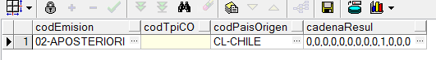

|  |  |  |  |
| --- | --- | --- | --- |
| **N° DEL REQUERIMIENTO FUNCIONAL Y NO FUNCIONAL** | **RIM** | **SOFTWARE** | **DATOS DE ENTRADA** |
| RF2 Reporte Detallado | El Reporte Detallado mostrará los Criterios de Búsqueda y permitirá exportar el resultado en Excel y PDF | Reporte Ejecutivo | Rango de fecha  Nro de Certificado Electrónico  Nro de Documento del Importador  Marca del Certificado  Tipo de Emisor  TPI  País de Origen |
|  | | | |
|  | | | |
| Se ingresa a la opción Reporte Detallado y se verificará que los filtros y el resultado de los reportes funcionen de acuerdo a lo solicitado en las reglas del RF2.  **RUTA OPCION:** Despacho aduanero de ingreso/Reportes/ Reporte Detallado Certificado      QUERY:  SELECT row_number() over(order by 1,2) AS "secuencia", "certificado", "fechaEmision", (select c.cod_datacat||'-'||c.des_datacat from datacatalogo c where c.cod_catalogo='COA' and c.cod_datacat= "COD_TIPEMISION") as "tipoEmision", "acuerdo", (select d.des_datacat from datacatalogo d where d.cod_catalogo='J2' and d.cod_datacat="COD_PAISENTHABILI") as "pais", (select f.cod_datacat||'-'||f.des_datacat from datacatalogo f where f.cod_catalogo='COB' and f.cod_datacat="IND_USOCERTORIGEN") as "marca", "dua", "fechaNumeracion","documentoImportador","razonSocialImportador" FROM ( SELECT repo.num_certorigen as "certificado", repo.fec_emiscertorigen as "fechaEmision", repo.cod_tipemision, ' ' as "acuerdo", repo.cod_paisenthabili, repo.ind_usocertorigen, ' ' as "dua", null as "fechaNumeracion", ' ' as "documentoImportador", ' ' as "razonSocialImportador" FROM doccertorigen repo WHERE repo.ind_usocertorigen!='D' */*CRITERIO 1 - Numero de certificado*/* AND repo.num_certorigen = ? */*CRITERIO 2 - Fecha de busqueda*/* AND trunc(repo.fec_emiscertorigen) BETWEEN trunc(?) AND trunc(?) */*CRITERIO 3 - Tipo de emision*/* */*CRITERIO 5 - Tipo de pais Origen*/* */*CRITERIO 6 - Marca del certificado de origen*/* UNION SELECT repo.num_certorigen as "certificado", repo.fec_emiscertorigen as "fechaEmision", repo.cod_tipemision, conv.cod_convenio as "acuerdo", repo.cod_paisenthabili, repo.ind_usocertorigen, decode(repo.ind_usocertorigen,'D',dam.cod_aduana||'-'||dam.ann_presen||'-'||dam.cod_regimen||'-'||lpad(dam.num_declaracion,6,'0'),' ') as "dua", decode(repo.ind_usocertorigen,'D', dam.fec_declaracion, null) as "fechaNumeracion", part.num_docident as "documentoImportador", part.nom_razonsocial as "razonSocialImportador" FROM doccertorigen repo left join cab_certiorigen cert on (repo.num_certorigen = cert.num_certificado and cert.ind_electronico = '1' and cert.ind_del = '0') left join cab_declara dam on (cert.num_corredoc = dam.num_corredoc) left join participante_doc part on (dam.num_corredoc = part.num_corredoc and part.cod_tippartic = '45') inner join docaut_asociado doc on (cert.num_corredoc = doc.num_corredoc and cert.num_secdoc = doc.num_secdoc and cert.cod_tipoper = doc.cod_tipoper and doc.num_doc=cert.num_certificado and doc.ind_del='0') inner join det_autorizacion det on (doc.num_corredoc = det.num_corredoc and doc.num_secdoc = det.num_secdoc and doc.cod_tipoper = det.cod_tipoper and det.ind_del = '0') inner join det_declara decl on (det.num_corredoc=decl.num_corredoc and det.num_secserie=decl.num_secserie and decl.ind_del='0') inner join convenio_serie conv on (conv.num_corredoc=decl.num_corredoc and conv.num_secserie=decl.num_secserie and conv.ind_del='0') WHERE cert.cod_tipoper='C' */*CRITERIO 1 - Numero de certificado*/* AND repo.num_certorigen = ? */*CRITERIO 2 - Fecha de busqueda*/* AND trunc(repo.fec_emiscertorigen) BETWEEN trunc(?) AND trunc(?) */*CRITERIO 3 - Tipo de emision*/* */*CRITERIO 4 - Tipo de acuerdo - TPI*/* AND conv.cod_convenio = ? */*CRITERIO 5 - Tipo de pais Origen*/* */*CRITERIO 6 - Marca del certificado de origen*/* GROUP BY (repo.num_certorigen, repo.fec_emiscertorigen, repo.cod_tipemision, conv.cod_convenio, repo.cod_paisenthabili, repo.ind_usocertorigen, decode(repo.ind_usocertorigen,'D',dam.cod_aduana||'-'||dam.ann_presen||'-'||dam.cod_regimen||'-'||lpad(dam.num_declaracion,6,'0'),' '), decode(repo.ind_usocertorigen,'D', dam.fec_declaracion,null), part.num_docident, part.nom_razonsocial) )    Parameters: [2540180113140, 2018-01-01 00:00:00.0, 2018-12-30 00:00:00.0, 2540180113140, 2018-01-01 00:00:00.0, 2018-12-30 00:00:00.0, 815]    EXPORTAR: | | | |

# CONCLUSIÓN

Se remitirá el pase a producción al área responsable del Control de Calidad para las pruebas del sistema correspondiente, toda vez que el resultado de las pruebas de desarrollo **fuese satisfactorio.**